Kavish Bhathija

18302335

Data Analytics – CS7DS1

Data Imputation Methods

29th December 2018

1. **Introduction**

The intent of this assignment is to decide which variables are the best predictor of the response variable. The target variable, that is the response variable as well as the predictor variables are not known. The target variable and predictor variables can be anything. For example, the target variable can be “if the person has cancer or not?” and the group variable (one of the predictor variables in the dataset) can be “gender” of the concerned person. For the purpose of this assignment, the response variable is considered to be deterministic of “will the person buy the house or not?”. Similarly, the variable Group is considered to be deterministic of the “Economic Class”. If the value of Group variable is 1, then he is considered as “Upper Class” and if the value of Group variable is 0, he is considered as “Middle class”. This example is taken just to make sense of the data and does not really represent the data in any way.

Apart from this, Multiple Imputations techniques are also compared to deal with the missing data in the dataset. Missing data is quite common in industry and a good data scientist must know how to deal with such a situation. For this assignment, three Imputation techniques are considered. They are KNN, Mice and Mean Imputation techniques (Explanation in further sections). To deal with missing data, it would be beneficial to know the type of missingness that can occur in a dataset. Basically, there are 4 type of missing data, which are described below (These are taken from CHAPTER 25: Missing Data, which was provided by the professor on the TCD Blackboard platform):

1. Missing Completely at Random: The probability of the data being missing is the same for every observation recorded. For example, if the people involved in a study decides to throw a dice at random and not to answer the question if 6 appears on the dice, it would be a case of Missing completely at random.
2. Missing based on missing value itself: This is also known as censorship. In this case, the missing value is concealed based on its own value. For example, if rich people decide not to reveal their income, it would become a case of Missing based on missing value itself. This creates bias in the model being fit to the dataset. This is the most difficult type of missingness to deal with.
3. Missing based on Unrecorded variables: Sometimes the data absent may depend upon some unobserved factor. For example, a person who is uncomfortable during the study may choose not to record his/her age. Now, the “comfort” is not recorded and hence, it becomes a case of Missing based on unrecorded variables.
4. Missing at random: There might be some pattern in the missing data, that is, it is missing at random but not completely at random. For example, people from low economic class may not report the size of their house or model of their car. This makes it a case of Missing at random. Generally, in the absence of any more information, missing data is considered to be of this type.

The performance of the various imputation techniques is measured with the help of a performance metric which includes the accuracy, precision, recall and F-score of different models, created on the imputed data achieved by using the imputation techniques being compared. Moreover, the performance metric is calculated with the help of various models. Random forest, Decision Tress and Logistic Regression models are used to compare the performance of the different imputation techniques being studied. This also helps in shedding some light on which model gives better performance as compared to the others.

1. **Description of the Dataset:**

The dataset has a total of 17 variables. They are Group, Response, ID, X1 to X7 and Y1 to Y7. Response Variable is our target variable and the rest are considered as the predictor variables. ID variable is dropped from the dataset because it just represents the serial order of all the observations in the dataset and for all practical purposes, can be considered as having no effect on our target variable whatsoever. The concerned dataset is not a huge dataset and has a total of 296 observations. To avoid variance problem in the model while evaluation of the performance metric, train test splitting has been used. The size of the training set is kept at 70% of the size of the dataset, thus it contains 207 entries. Similarly, the size of the test set becomes 30% of the total size of the dataset and therefore, contains 89 observations. The various variables are summarized in the table below.

|  |  |  |
| --- | --- | --- |
| Variable Name | Data Type | Number of missing values |
| ID | Continuous | 0 |
| Response | Categorical | 0 |
| Group | Categorical | 0 |
| X1 | Continuous | 4 |
| X2 | Continuous | 130 |
| X3 | Continuous | 131 |
| X4 | Continuous | 0 |
| X5 | Continuous | 4 |
| X6 | Continuous | 63 |
| X7 | Continuous | 24 |
| Y1 | Categorical | 4 |
| Y2 | Categorical | 130 |
| Y3 | Categorical | 131 |
| Y4 | Categorical | 0 |
| Y5 | Categorical | 4 |
| Y6 | Categorical | 63 |
| Y7 | Categorical | 24 |

Table 1. Description of variables in the dataset

1. **Exploratory Data Analysis and Pre-processing**

As mentioned earlier, ID variable has been dropped from the dataset because it is just the serial number of the observations and does not have any effect on the target variable, for all practical purposes. The number of missing values is the same in the corresponding X and Y pairs. For example, both X1 and Y1 have 4 missing values in the dataset. Therefore, the correlation between corresponding X and Y needs to be checked.

* 1. **Correlation between corresponding X and Y features**

The relationship between the corresponding X and Y pairs is studied with the help of Logistic regression. The logic behind using logistic regression is simple. If the correlation is high between the corresponding X and Y variables, then X will be a great predictor of Y. Logistic regression is used for the said prediction because Y is a categorical variable and X is a continuous variable. Instead of using logistic regression to find the correlation between the corresponding pairs of X and Y, we could have used point biserial correlation and Krusal H test as well. But for simplicity purposes, we have used logistic regression test as a measure of correlation. To be specific, the accuracy and F-score has been used as a measure of correlation using logistic regression. If the accuracy and F-score is high, then the pair is highly correlated and if its low, they are not correlated. Also, it should be noted that pearson correlation would not be a good indicator of correlation here because we are comparing a continuous and a categorical variable. The result of this test is as tabulated below.

|  |  |  |
| --- | --- | --- |
| X and Y pair | Accuracy | F-Score |
| X1 & Y1 | 1 | 1 |
| X2 & Y2 | 0.75 | 0.83 |
| X3 & Y3 | 0.73 | 0.78 |
| X4 & Y4 | 0.61 | 0.58 |
| X5 & Y5 | 0.79 | 0.87 |
| X6 & Y6 | 0.81 | 0.76 |
| X7 & Y7 | 0.73 | 0.70 |

Table 2. Accuracy and F score of X and Y pairs using logit regression

As can be seen from the table above, X1 and Y1 are highly correlated. All the other pairs are moderately correlated with the exception of X4 and Y4. X4 and Y4 are not much correlated since they show an accuracy of only 0.61 and F-score of only 0.58.

* 1. **Outlier Detection**

The outliers can be identified using box plots. The box plot is created using the “boxplot” function in R. It is inbuilt in R, that is, it is a part of the default packages in R. The box plot is as shown below.



Figure 1. Box plot of the dataset

From the boxplot, it can be inferred that the variables X1, X2, X3, X4, X6 and Group have the presence of outliers in it. Out of these, the maximum outliers are present in X2 and X3 features. Thus, it would be sensible to use top encoding with these features.

* 1. **Correlation matrix and Feature Selection**

A correlation matrix is generated to study the correlation between the various features present in the dataset. If the correlation is high between any two variables, one of them can be dropped to make the model as simple as possible. The correlation matrix is generated using ‘corrplot’ library in R.

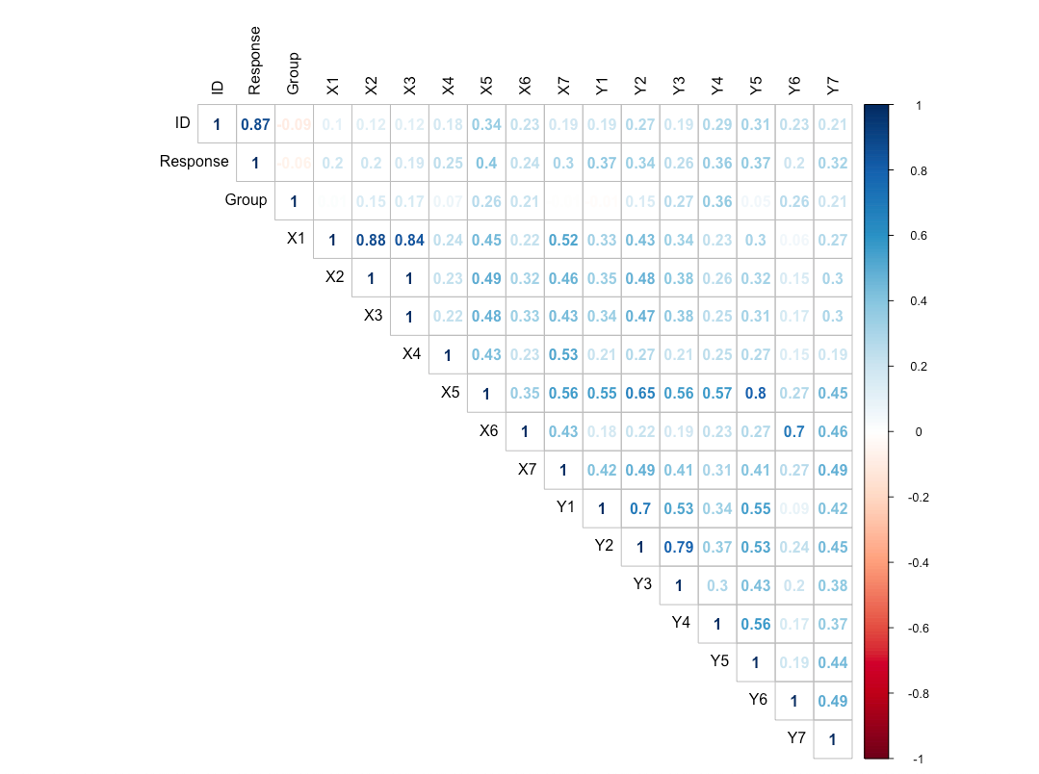

Figure 2. Correlation matrix

It can be inferred from the above matrix that X1, X2 and X3 are highly correlated with each other. Thus, it would be a good idea to use only one out of these three variables for simplicity of the model.

Finally, X2, X3, Y1, Y5 and Y6 variables are dropped as part of feature selection. X2 and X3 are dropped because X1, X2 and X3 show high correlation and out of these, only 1 variable would be enough. Instead of X1, either of X2 and X3 could have been kept. Y1, Y5 and Y6 are dropped because X1, X5 and X6 show high correlation with Y1, Y5 and Y6, as can be seen from table 2. Thus, the final list of predictors selected after Feature selection are Group, X1, X4, X5, X6, X7, Y2, Y3, Y4 and Y7.

* 1. **Exploration of Missingness in features**

As mentioned above, individual features have different number of missing values. A visualization of the same is given below. The plot is generated using the “aggr” function found in the “VIM” library of R.

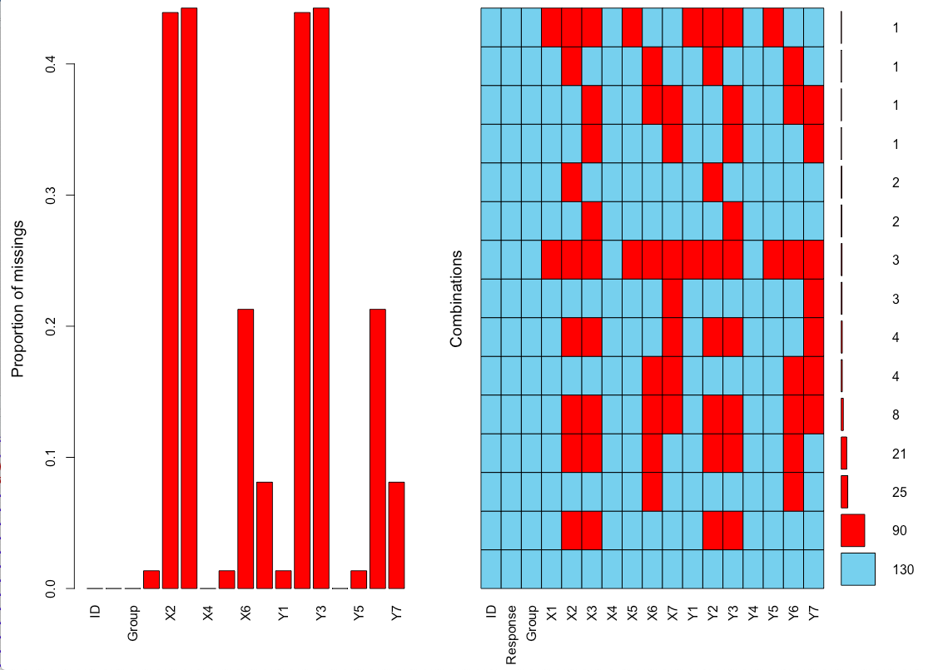

Figure 3. Visualization of the missingness in dataset

As can be seen from the plot above, the maximum missingness is seen in X2, X3 and Y2, Y3 features. ID, Response, X4, Y4 and Group variables show no missingness. It can be seen from the plot as well that the number of missing values in the corresponding X and Y pairs are the same. It should be noted that dropping the missing values won’t be a good idea. This is because there are almost 50% of the values that are missing from the dataset. Dropping the columns with the maximum missingness also wouldn’t give good performance, because there is a total of 4 such columns (with high missingness). Moreover, these columns might be good predictors of our target variable.

* 1. **Exploration of the distribution of individual features**

The distribution of the various continuous variables is visualized using histograms and the distribution of the categorical variables is studied using box plots. The histograms are generated using the “hist” function from the default R library and the boxplots are generated using the “boxplot” function from the default R library. The visualizations are given below.









Figure 4. Histograms of Continuous variables

It can be inferred from the above histograms that the data points in most of cases show a skewed behavior. By skewed, it is meant that the distribution of the data is uneven. It is more on one side and less on the other. Moreover, the range of the different variables vary greatly. For example, the range of the feature X7 is from 1 – 10000, but the range of the feature X6 is only from 1 – 10. Thus, it would be a good idea to use standardization technique. It will also be helpful since we are using categorical and continuous variables together to predict the target variable.









Figure 5. Bar Plots of Categorical Variables

The distribution of categorical variables does not seem skewed, as can be seen from bar graphs above. Thus, they require no feature scaling.

* 1. **Relationship between features and target**

The relationship between features and target is visualized using scatter plots. These plots are generated using “ggplot” function of the ggplot2 library in R. The effect of the individual variable on the target variable can be measured by the performance metric generated when a model is fitted using just that particular variable. The performance metric include accuracy, precision, recall and F-score. The model that is fitted to study the effect of the variable is random forest. The results of the same are summarized in the table below.

|  |  |  |  |  |
| --- | --- | --- | --- | --- |
| Feature | Accuracy | Precision | Recall | F-score |
| X1 | 0.6516854 | 0.6516854 | 0.673913 | 0.6666667 |
| X2 | 0.6741573 | 0.5925926 | 0.8205128 | 0.688172 |
| X3 | 0.7303371 | 0.7894737 | 0.6521739 | 0.7142857 |
| X4 | 0.5617978 | 0.6046512 | 0.5416667 | 0.5714286 |
| X5 | 0.6629213 | 0.6607143 | 0.7708333 | 0.7115385 |
| X6 | 0.6404494 | 0.6111111 | 0.75 | 0.6734694 |
| X7 | 0.6292135 | 0.625 | 0.6666667 | 0.6451613 |
| GROUP | 0.4044944 | 0.440678 | 0.5652174 | 0.4952381 |
| Y1 | 0.741573 | 0.8297872 | 0.7222222 | 0.7722772 |
| Y2 | 0.7191011 | 0.71875 | 0.8679245 | 0.7863248 |
| Y3 | 0.6853933 | 0.673913 | 0.7045455 | 0.6888889 |
| Y4 | 0.6853933 | 0.6590909 | 0.6904762 | 0.6744186 |
| Y5 | 0.7752809 | 0.7752809 | 0.8235294 | 0.8076923 |
| Y6 | 0.6179775 | 0.6458333 | 0.6458333 | 0.6458333 |
| Y7 | 0.6966292 | 0.7297297 | 0.6136364 | 0.6666667 |
| X1 & Group | 0.6741573 | 0.7068966 | 0.7735849 | 0.7387387 |
| X2 & Group | 0.7078652 | 0.75 | 0.72 | 0.7346939 |
| X3 & Group | 0.752809 | 0.6545455 | 0.9230769 | 0.7659574 |
| X4 & Group | 0.7191011 | 0.6363636 | 0.9767442 | 0.8251234 |
| X5 & Group | 0.752809 | 0.7083333 | 0.8095238 | 0.7555556 |
| X6 & Group | 0.5505618 | 0.5636364 | 0.6595745 | 0.6078431 |
| X7 & Group | 0.6629213 | 0.6415094 | 0.7555556 | 0.6938776 |
| Y1 & Group | 0.7191011 | 0.7948718 | 0.6458333 | 0.7126437 |
| Y2 & Group | 0.6629213 | 0.6428571 | 0.7826087 | 0.7058824 |
| Y3 & Group | 0.7191011 | 0.7692308 | 0.754717 | 0.7619048 |
| Y4 & Group | 0.6404494 | 0.6052632 | 0.575 | 0.5897436 |
| Y5 & Group | 0.741573 | 0.7555556 | 0.7391304 | 0.7472527 |
| Y6 & Group | 0.5842697 | 0.5535714 | 0.7209302 | 0.6262626 |
| Y7 & Group | 0.6741573 | 0.7586207 | 0.5 | 0.6027397 |

Table 3. Performance Metric of Individual Variables

As can be seen from the table, the maximum effect seems to be of variables Y1, Y2 and X3. Interestingly, the effect of individual variable Group is the lowest on the target variable “Response”, but when it is clubbed with other variables, the performance of the model generally increases. For example, the accuracy and the F-score of the variable X4 is 0.56 and 0.57 respectively, if it used to predict the target variable individually. But when it is clubbed together with the feature Group, it’s accuracy and F-score increases to 0.71 and 0.82 respectively. Although, in some cases the performance decreases as well. For example, in the case of the variable Y6, the accuracy and F-score is 0.61 and 0.64 respectively. But when it is clubbed together with the variable Group, its accuracy and F-score decreases to 0.58 and 0.62 respectively.

It’s hard to infer anything from the plots generated to visualize the relationship between features and the target variable. The plots are given below.





Figure 6. Plots for visualization of relationship between features and target

1. **Baseline Accuracy**

A base model is created including all the available observations. This model is created as a basis to compare the effects of top coding, standardization and feature selection. This model is a decision tree model. The choice of model is arbitrary and can be anything. The model could have been chosen as logistic regression model or Random forest model as well. The effect of the same on this model is visualized in the table below.

|  |  |  |  |  |
| --- | --- | --- | --- | --- |
| Method (DT) | Accuracy | Precision | Recall | F-Score |
| Baseline | 0.6966292 | 0.6956522 | 0.7111111 | 0.7032967 |
| Top Coding | 0.7640449 | 0.7454545 | 0.8541667 | 0.7961165 |
| Standardization | 0.741573 | 0.6964286 | 0.8666667 | 0.7722772 |
| Feature Selection | 0.6853933 | 0.7317073 | 0.6382979 | 0.6818182 |
| Top coding, Standardization and Feature Selection | 0.7752809 | 0.7906977 | 0.7555556 | 0.7727273 |

Table 4. Baseline Performance Metric comparison

From the table above, it can be inferred that the best accuracy is recorded when top coding is applied. The data is top coded to the maximum value of 1000. To realize top coding, the “topcode.data” function is used from the networkreporting library in R. Furthermore, not much difference in performance metric is observed when feature selection is realized and hence, the validity of feature selection is justified. Although, since our dataset is not very large, we could have skipped feature selection. When top coding, feature selection and standardization are done on top of each other, the best results are achieved. This is an expected result.

1. **Missing Data Imputation**

It should be noted that dropping the data with missing rows would not yield good performance here. This is because the proportion of missing data is high. Missing Data is imputed using three techniques. For each imputation technique, three different models are realized using the imputed data. The models being realized for this assignment are as follows:

1. Decision Tree Model: It is a machine learning algorithm which creates a “tree” like structure to make predictions on new observations. The “tree” like structure is created using simple questions such as “male or not?” or “rich or poor?”.

1. Random Forest Model: It is an ensemble supervised learning algorithm which aggregates the result achieved from various decision trees created. The result of this algorithm is generally better than that of a Decision Tree Model.

1. Logistic Regression Model: It is another machine learning algorithm which can be seen as an advanced version of linear regression which is used for classification purposes. This model predicts probabilities for classification.

There are multiple imputation techniques which are used in the industry to deal with the missing data. Some of the most commonly used imputation techniques are as follows:

1. Mean Imputation
2. Median Imputation
3. Hot-Deck Imputation
4. Cold-Deck Imputation
5. KNN Imputation
6. Two stage Modelling Imputation
7. Mice Imputation
8. Amelia

For the purposes of this assignment, we have utilized mean imputation, KNN Imputation and Mice Imputation. They are explained below.

1. Mean Imputation:

This is the one of the most basic type of imputation possible. This type of imputation generally does not yield good results. In this imputation technique, each missing variable is replaced by the mean of the observations. The mean is calculated using observations which are not missing. The reason this technique does not perform very well because it reduces the deviation and variance of the data and hence, can affect the shape of the data. The advantage of using this type of imputation technique is that it is very simple to implement and fast to achieve.

The performance metric of the mean imputation technique is given in a table form below. The maximum accuracy of 74.2% is achieved by the Random Forest model. The least good performance is shown by Decision tree Model which achieves an accuracy of 69.2%. Although all the models show some difference in accuracies, but the difference in F-score isn’t much as compared to the accuracy.

|  |  |  |  |  |
| --- | --- | --- | --- | --- |
| Model (Mean) | Accuracy | Precision | Recall | F-score |
| Random Forest | 74.2 | 70.9 | 84.8 | 77.2 |
| Decision Tree | 69.7 | 66.1 | 84.8 | 74.3 |
| Logistic Regression | 72.9 | 68.3 | 89.1 | 76.8 |

Table 5. Performance Metric for Mean Imputation

1. KNN Imputation:

KNN is an acronym for K- Nearest Neighbor Imputation. It is also one of the most basic imputation techniques used in the industry. The advantage of using this imputation method is that it is very fast, easy to implement and give relatively better results as compared to mean imputation. This method does not change the variance of the dataset. In this method, the dataset is mapped. For a new observation, ‘K’ closest points to the new observations are considered and prediction given based on the values of these neighbors. For classification, the predicted value is the maximum frequency of the value of the ‘K’ nearest points. For Regression, the predicted value is the mean of the value of the ‘K’ nearest points. The measure of closeness is taken as Euclidean distance. The correct choice of the value of K vary from dataset to dataset. Generally, it varies from 1 to 10.

For the purpose of our assignment, we have taken the value of K as 10. The table summarizing the performance metric calculated on the basis of data imputed using KNN Imputation method is as below. The best performance is given by Random Forest model which achieves an accuracy of 77.5% and achieves a F-score of 79.3%. The least good performance is shown by Decision Tree Model, which achieves an accuracy of just 68.5% and a F-score of 71.4%. This type of imputation yields better performance metric than mean imputation, as expected.

|  |  |  |  |  |
| --- | --- | --- | --- | --- |
| Model(KNN) | Accuracy | Precision | Recall | F-score |
| Random Forest | 77.5 | 79.2 | 78.9 | 79.3 |
| Decision Tree | 68.5 | 70 | 72.9 | 71.4 |
| Logistic Regression | 73 | 75 | 74.3 | 74.9 |

Table 6. Performance Metric for KNN Imputation.

1. MICE Imputation:

MICE is an acronym for Multivariate Imputation using Chained Equations. This is a very popular package in R, which can perform imputations using multiple techniques. The various techniques that can be used in MICE Imputation are: Predictive Mean Matching(pmm), Logistic Regression(logreg), Bayesian Polytomous Regression(polyreg) and Propotional Odds Model. It works by creating multiple imputation models and then combining their result together. This helps in reducing uncertainty. MICE Imputation assumes that the data missing is of the type Missing at Random.

For the purpose of this assignment, we have used Predictive Mean Matching(pmm) method. The summary of the models created using data imputed with MICE is given in the table below. As can be seen from the table below, the best performance metric is given by the Random Forest model. The accuracy and F-score achieved by Random Forest is 82% and 85.5% respectively. The least good Performing model is Logistic regression which achieves an accuracy of 67.4% and a F-Score of 73.4%. This is in contrast with the other two imputation techniques where Decision Tree was the worst performer out of the three models compared. The models created using the MICE imputation method achieves the best result, when compared to Mean and KNN imputation methods.

|  |  |  |  |  |
| --- | --- | --- | --- | --- |
| Model(MICE) | Accuracy | Precision | Recall | F-score |
| Random Forest | 82 | 83.9 | 87 | 85.5 |
| Decision Tree | 70.8 | 75.9 | 76.1 | 76 |
| Logistic Regression | 67.4 | 72.7 | 74.1 | 73.4 |

Table 7. Performance Metric for MICE Imputation

1. **Conclusion**

To summarize, imputation generally led to a better performance metric as compared to the baseline model, which was created by excluding the observations with missing values. Preprocessing of Data improved the performance metric, as is expected. Preprocessing techniques used were – Standardization, Feature Selection and Top coding. Preprocessing Improved the accuracy from 0.69 to 0.77.

Random Forest Model consistently outperformed the other two models. It is expected because random forest is an ensemble method and works by using “bagging”, that is it works by creating multiple decision tree models and aggregating their results to predict a value. This reduces uncertainty. The least good performance is shown by Decision tree in the case of KNN and Mean Imputation. In the case of MICE Imputation, logistic regression model gives the least good performance. Thus, the worst performing model is not consistent.

Out of the three imputation methods compared, MICE Imputation method gave the best results, followed by KNN Imputation. The worst results were shown by mean Imputation method. It may be possible that the performance metric achieved for different methods is dependent on the shape and size of the dataset. Thus, no conclusions should be made with the use of just one dataset.

For the purpose of this dataset, it was assumed that the data missing is of the type Missing at Random. In future work, it would be beneficial to find out what type of missing data is there in the dataset. Also, in KNN Imputation method, comparison is made using only one value of K. It is be recommended to compare models using multiple values of K.